**KV’s Movie Reviews App**

**Project Overview**

After doing a website on Wix last semester for this class, I was thinking about what type of project I should do for this class. Last semester, I had a class called Multimedia Design 2, where we had to design an app for small furniture company, so I did my app design on a fictional company called KV’s Furniture app. While working on that app, I realized that I loved creating apps on Figma program. So, when I was thinking of what type of project I should do for this, I decided to design another app. This time, I had a choice on what type of app I should do, so since I love movies and I also love reading reviews, I decided to do this app on movie reviews, where a user can read & write a review. So, I focused on that aspect only while designing this app.

**Project Goal**

As I mentioned before I would be designing a movie reviews app for this project and first task was to think of a name for it. Since, I called my last semester furniture app as KV’s Furniture; I decided to call this app as **KV’s Movie Reviews**.

I did some research on different types of movie review apps, but, I found that some of those apps are complicated and some of them like IMDb, has more reviews and popular. So, I wanted this app to be just that the users can read & write the reviews, nothing more than that. Plus, I wanted this app’s UX to be very simple and very fast to use. I also planned the functions to be very similar like the other apps, there won’t be any confusion for the user.

And the target audience for this particular app are movie lovers and those people whose lives are busy and don’t want to waste their time on bad movies. I designed this app keeping this target audience in mind. For movie lovers, I used attractive movie posters to attract this audience and I used fast paced UX for those who are very busy so to make it easier for them.

**Creative Process**

**Logo Design**

So, after I thought of a name for the app, next thing I needed to was to design a logo. I used Adobe Illustrator to design my logo I made 3 different variations of the logo to choose from. And since this is an app more on movies, I wanted to have something to signify it. So I chose popcorn an icon to represent that and I used Photoshop to create popcorn and then brought into Adobe illustrator. The following is the first variation.

The next variation logo wasn’t changed that much. I tried to add color as background to see how it looks like. I tried different colors, and then I decided to go with light white.

The light white color didn’t add that much. So, I made a final version of the logo, as below.

As you can see that I changed the size and the color of the popcorn to make it bit colorful. So, decided to go with this one for now. And after a while, getting a feedback from some of my peers and my professor, to reduce the size of the popcorn and place the text beside the popcorn, not on the popcorn. So, I tried it out and it turns out better, and then I decided to go with this one as the final logo.

.

I was completely satisfied with this design and started the next step.

**Ideation**

**Personas**

For my previous project app KV’s Furniture, I had to do some ideation work, like user personas, user flow & style Tile. I started with two different personas, one a guy who’s a doctor and doesn’t have lot of time and doesn’t like to waste time on movie that are bad. I also pointed out pain points, his strengths, interests & goals.

The second persona is a girl who is a film student and loves watching movies and also loves to writing reviews and reading reviews. I also pointed out her pain points, interests & goals.

**User Flows**

I also did user flow to show the path of a user getting to one place to another on the app. It starts with the user landing on to the app, logging in or skipping and going to home page and the process from there. Doing this user flow helps me to see how many pages are required for each task. And also helped me to how long it would take.

**Style Tile**

And the last one in the ideation was to do design a style tile, show the fonts I use, types of images to use and what colors will be used as well. This will help me to keep track on things I will need for designing and so I won’t forget anything. This is also a good way to show programmers who will be coding the actual app to help them what they will need.

**Sketches**

After the logo was done, the next task was to sketch out the basic app screens. So I printed out phone sketch pages to do the sketches like these.

As you can see from these basic sketches, they show where the navigation bar would be and where the logo & images would be placed. And some basic buttons as well. Doing these sketches helped me visualize the design properly and helped me to see how this design would look like and to see if there’s any change to be made.

**TECHNOLOGY USED**

* Adobe Illustrator – Used to design the logo.
* Adobe Photoshop – Used also design the logo.
* Figma – Used to design site app.

**RESOURCES USED**

* YouTube (tutorials)

**Production**

**Low Prototype**

So, finally I got started designing in Figma app. I designed low, mid & high fidelity prototypes. Low fidelity means just showing of the page where labeling where each element will need to be without actually having those elements there like typography, images etc. This helped me to see how the basic layout will look like.

**Medium Prototype**

And for the medium fidelity prototype, I designed using the same low fidelity prototype. Since, I already planned where each will be placed, I started with typography and placing the text at their appropriate places. This will help me even more to see how the texts are aligning with the pages. It also helps to see which typeface to use.

**High Prototype**

And finally onto the high prototype where I added all elements to the pages, like images, icons & colors. I started with navigation first and placed icons at the bottom of the screen. I used free icons I found on the internet and I found same icon family, where they’re all look the same.

Then, I started working on the header itself, I added my logo at the top right corner of the screen and also added Login & Logout icons at the top left corner and as well made them small to fit on the header.

Then I started working on main home page and I build a grid of 9 boxes and started adding the recent movie posters and added starts to give a rating for each movie. I also made the posters all same sizes for consistency. I originally added a collage of movie posters as the background, but given some suggestions of my peers & my professor, I decided to remove that have it just plain black as a background.

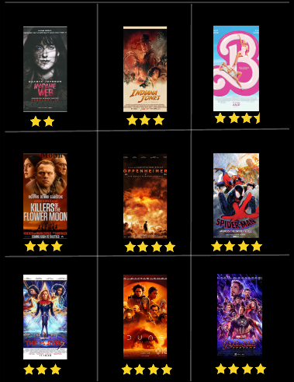

And if the user wants to read reviews on any of the movies there, what they all have to do is click on the movie poster and it will take them to that movie reviews screen. This page will have all of the recent movie reviews written by the users in a short form. If the user wants to read the whole review, all they have to do is to show more beside the text, it will take them to the whole review.

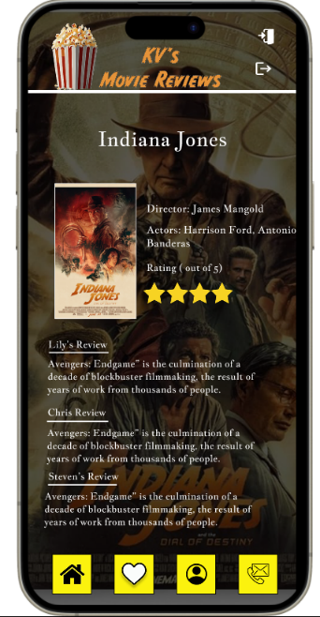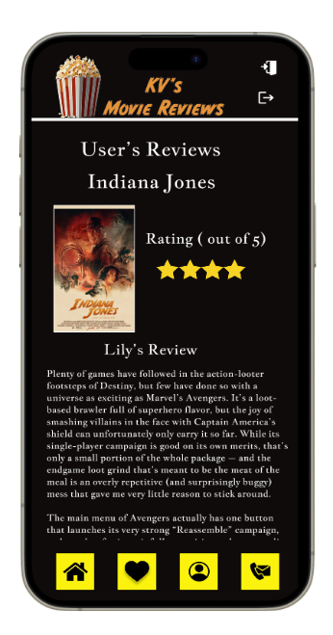

And if the user wants to read reviews on any of the movies there, what they all have to do is click on the movie poster and it will take them to that movie reviews screen. This page will have all of the recent movie reviews written by the users in a short form. If the user wants to read the whole review, all they have to do is to show more beside the text, it will take them to the whole review.

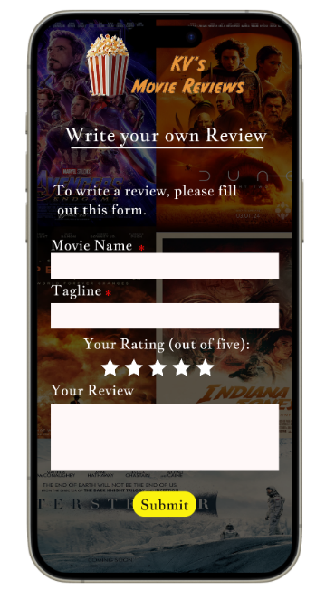

**Final Deliverable**

**Link to final prototype:**

<https://www.figma.com/proto/sYb0DHk9zsYORr7ObokRIx/KV's-Movie-Reviews-2?page-id=0%3A1&type=design&node-id=482-84&viewport=-125%2C182%2C0.12&t=oOtdO4Ww3u8PdG7P-1&scaling=scale-down&starting-point-node-id=406%3A2341&mode=design>

**Reflection**

For this project, I planned in such a way that I was able to achieve my goal of designing an app for movie reviews. I achieved all of the tasks I planned out for myself and also on time as well. I am happy because I was able to do the project that I am interested in. Through this process, I learned a lot about app design, color pallets and more.

And at the same time, I did face some challenges on the Figma program, like some functions that I didn’t know, so I have to watch some on YouTube tutorials and get help from peers. For example, I didn’t know how the scroll works on Figma, so for that, I have to get help for some peers, other than that I didn’t really face that many issues.

As I mentioned earlier before that I learned more about app design & color palette like what color works well with what and such kind of stuff. Apart from that, I also learned more about Figma program and more of its functionality. I also learned where and when to place icons effectively and other related stuff.

And by doing this project, it gave me a confidence that I am capable of designing apps. And that’s something I learned about myself too. What I also learned about myself was that I have lot of good ideas for apps, but I still need some suggestions from peers so to help me to become a better designer. I will definitely continue doing more app designs and hopefully able do it for living in the future.